Oral Report Script: *Measuring the Impact of Government R&D Contracts* by John Ahlin

---

#### Opening (1-2 minutes)

“Good [morning/afternoon], everyone.

The paper I’m discussing today investigates the impact of government R&D contracts on manufacturing productivity. Specifically, the author aims to quantify how much these contracts influence productivity, as measured by Total Factor Productivity (TFP), and the time lag for these effects to materialize. Using data from the Federal Procurement Data System (FPDS) and the NBER-CES Manufacturing Industry Database, the author creates a mapping between government spending and specific manufacturing industries. The analysis proposes a regression framework to link past R&D spending with future productivity growth.

The research question is both timely and practical, with direct implications for how policymakers allocate R&D funding.”

“One of the central elements of this paper is the regression model designed to measure the effect of government R&D spending on industry-level productivity. The author’s approach involves aggregating Total Factor Productivity (TFP) growth over five years as the dependent variable and using the sum of R&D spending over the preceding five years, normalized by industry shipments, as the primary independent variable.

The regression specification includes industry fixed effects (ai​) to control for unobserved, time-invariant industry-specific factors, and year fixed effects (gamma t​) to account for macroeconomic trends that might influence all industries equally. The error term (epsilon i t​) captures unobservable shocks to productivity. Formally, the model is specified as:

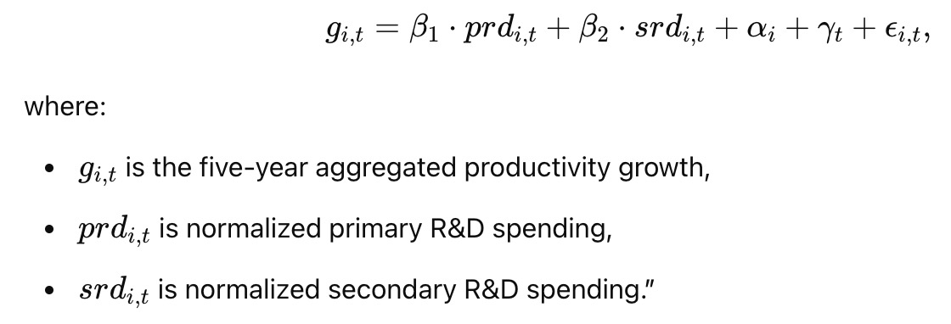

---

“This regression setup is a strong starting point. It addresses key econometric considerations, such as fixed effects, to minimize bias. Normalizing R&D spending by industry shipments ensures comparability across industries of different sizes. However, there are areas where the model could be improved.”

#### Critique Highlight and Suggestion (2 minutes)

“One key issue I would like to focus on is the incomplete calculation of the TFP variable, which is critical for the regression analysis. The author notes challenges replicating the NBER TFP values, resulting in a lack of regression results, which are essential to substantiate the study’s claims.

To address this, I suggest simplifying the approach to calculating TFP while consulting directly with the dataset's authors or related experts to troubleshoot the discrepancies. Alternatively, the author could consider using a proxy for productivity growth, such as gross output per worker, to provide preliminary results while working to resolve the ΔTFP issues. This would allow the analysis to proceed and generate insights even if the perfect replication of TFP remains incomplete.

Additionally, introducing descriptive statistics or visual trends comparing R&D spending and productivity growth across industries would strengthen the paper in the interim.”

Potential Endogeneity Concerns:

"Another key issue is potential endogeneity in the relationship between R&D spending and productivity. For instance, more productive industries might attract more government R&D contracts, leading to reverse causality. This could bias the estimates of

beta 1 and beta 2. Instrumental variable (IV) techniques could be employed, such as using lagged political variables or R&D allocations based on historical spending patterns, to address this concern."

---

#### Conclusion and Transition to Q&A (1 minute)

“In summary, this paper tackles an important question with a creative methodology but is currently limited by the lack of complete results. My main recommendation is to prioritize resolving the ΔTFP calculation issue or introduce proxies and preliminary analyses to progress the study.

Now, I’ll open the floor to questions.”

---

#### Q&A (5 minutes)

**Possible Questions and Responses:**

1. **Q:** "Do you think the methodology is fundamentally flawed if TFP cannot be replicated?"

- **A:** "Not necessarily. The methodology is sound overall, but the TFP calculation is a bottleneck. Alternatives like proxies for productivity growth could keep the analysis moving while TFP replication is resolved."

2. **Q:** "How critical is the PSC to NAICS crosswalk in this analysis?"

- **A:** "It's a foundational part of the methodology, and the manual effort adds credibility. However, refining or automating the crosswalk could ensure consistency and scalability."

3. **Q:** "Would endogeneity concerns invalidate the results?"

- **A:** "Addressing endogeneity is essential, but it can be managed with instrumental variables or fixed effects. The current draft doesn't address it but has room to do so."

---

This structure ensures a concise and engaging presentation while leaving room for interactive discussion during Q&A.